Tony – Q1 & Q5
Steffen – Q2 & Q6
Ann – Q3 & Q7
Kathleen – Q4 & Q8

Part A: Review
Question 1
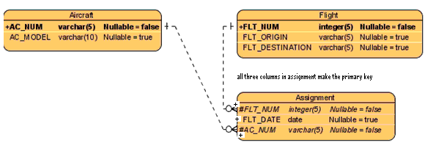
- Are the relationships in this ERD strong or weak?
These relationships are both strong (a.k.a identifying) because the both of the foreign keys in Assignment are part of that entity’s primary key.
- Which entities are strong and which are weak? Why?
Entity “Assignment” is weak because it’s primary key is mostly composed of foreign keys from “Aircraft” and “Flight”, and therefore cannot exist with those tables.
- What changes are needed to this ERD to show strong vs. weak entities and strong vs. weak relationships?
The entity “Assignment” needs a double border around it to indicate that it is weak. Both of the relationships need to be drawn with solid lines to indicate that they are strong.
- Draw the class diagram equivalent to the following ERD. Include multiplicity. Paste a screenshot of your result here:
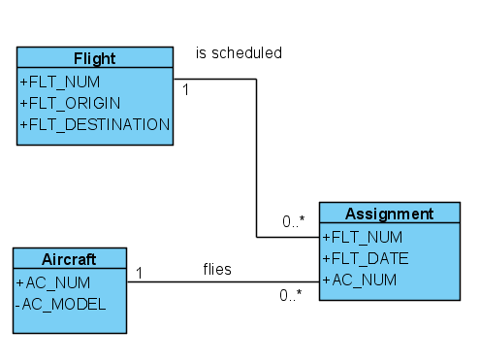
- List business rules behind your association and multiplicity.
1) Each assignment must have exactly one aircraft, and one flight.
2) An aircraft can fly any assignment, but does not have to fly any.
3) A flight can be scheduled at any time, but does not have to be scheduled at all.
- List the participation for each association
Assignment is optional to Aircraft. Aircraft is mandatory to Assignment.
Assignment is optional to Flight. Flight is mandatory to Assignment.

Question 2 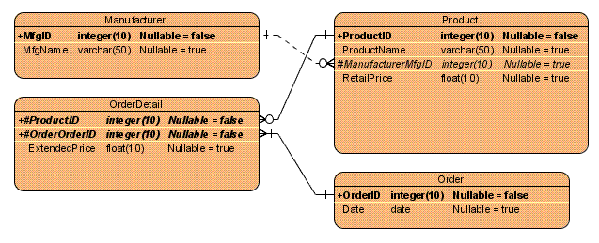
a) Are the relationships in this ERD strong or weak?

The relationships are strong because both the foreign keys in “OrderDetail” are part of that entity’s primary key.
(Steffen)

b) Which entities are strong and which are weak? Why?

The “OrderDetail” entity is weak because it could not exist without the tables from which it derives its concatenated primary key. The “OrderDetail” entity would have no meaning independent of the “Order” or “Product” entities. The “Order” entity is also weak as it would also be meaningless without the “OrderDetail” entity.

The “Product” and “Manufacturer” entities are all strong entities as they would all retain their meanings even without the “Order” and “OrderDetail” entities.
(Steffen)

c) What changes are needed to this ERD to show strong vs. weak entities and strong vs. weak relationships?

Weak entities would be shown with an extra border (i.e. the “Order” and “OrderDetails” entities). The relationships are correct as they are.
(Steffen)

c) Draw the class diagram equivalent to the following ERD. Include multiplicity. Paste a screenshot of your result here:

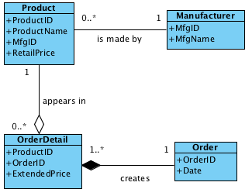
(Steffen)

d) List business rules behind your association and multiplicity.

1. Each order creates one or more order details.
2. Each order detail contains one product.
3. Each product in stock is made by one manufacturer.
(Steffen)

e) List the participation for each association.

OrderDetail is optional to Product, but Product is mandatory to OrderDetail.
Order is mandatory to OrderDetail.
Manufacturer is mandatory to Product, but Product is optional to Manufacturer.
(Steffen)

Question 3

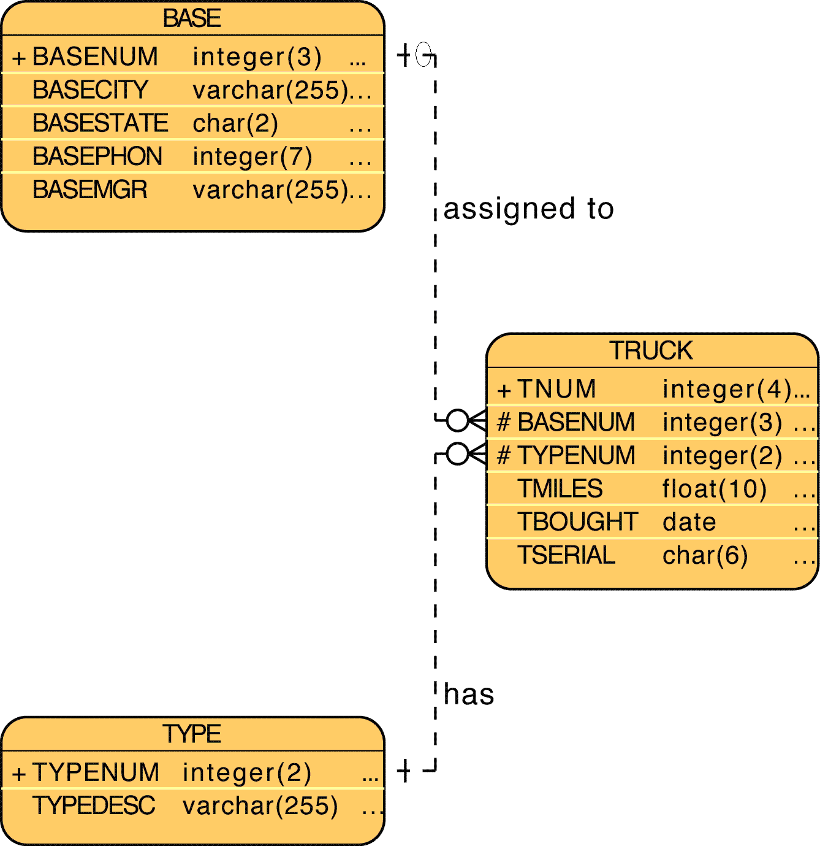

a) Are the relationships in this ERD strong or weak?
b) Which entities are strong and which are weak? Why?
c) What changes are needed to this ERD to show strong vs. weak entities and strong vs. weak relationships?
c) Draw the class diagram equivalent to the following ERD. Include multiplicity. Paste a screenshot of your result here:
d) List business rules behind your association and multiplicity.
e) List the participation for each association

Question 4
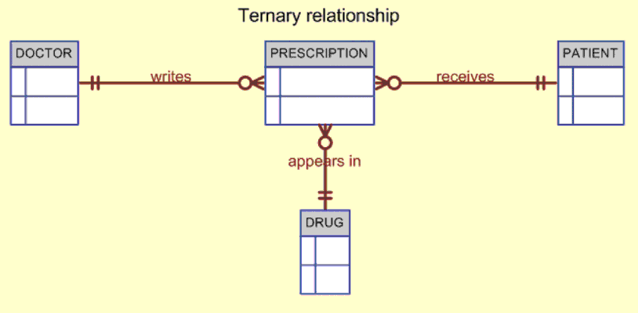

a) Are the relationships in this ERD strong or weak?
The relationships in this ERD are strong, as indicated by the solid line between entities in the Crow’s Foot model. (Kathleen)

b) Which entities are strong and which are weak? Why?
It is not possible to identify which of the entities in this diagram are weak because the diagram does not show which entity derives its primary key from the other entity in the relationship. (Kathleen)

c) What changes are needed to this ERD to show strong vs. weak entities and strong vs. weak relationships?
The strength of relationships in Crow’s Foot models such as this one is clear from the type of line between entities. A solid line indicates a strong relationship and a dashed line indicates a weak relationship. Therefore, no changes are needed to clarify strong vs. weak relationships in this diagram.

Although a strong relationship indicates a weak entity, it is unclear from this diagram which of the entities in each relationship is weak. This diagram would have to show which entity derives its primary key from the other in order to identify the weak entity. In other words, the diagram should list the primary and foreign keys for each entity. (Kathleen)

c) Draw the class diagram equivalent to the following ERD. Include multiplicity. Paste a screenshot of your result here: 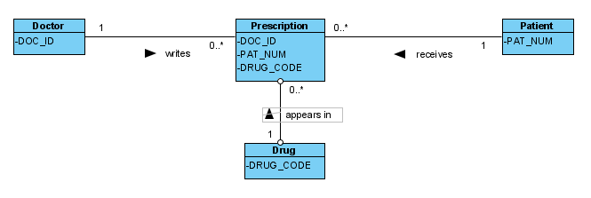
(Kathleen)

d) List business rules behind your association and multiplicity.
- A doctor writes zero or more prescriptions; each prescription is written by a doctor.
- A patient may receive zero or more prescriptions; each prescription is given to a patient.
- A drug may appear in zero or more prescriptions; each prescription contains only one drug.
(Kathleen)

e) List the participation for each association
- Prescription is optional to Doctor; Doctor is mandatory to Prescription.
- Prescription is optional to Patient; Patient is mandatory to Prescription.
- Prescription is optional to Drug; Drug is mandatory to Prescription.
(Kathleen)

Question 5
Say you work for a company that operates several types of vehicles. Last time you counted, there were 23 different types of license classifications that your employees could have. Several employees have multiple types of vehicle licenses. To store this information in the employee table, the original database developer just kept adding more licence type columns to the employee table.
What problem do you see with this practice?
- Adding columns can slow down processing, and increase storage requirements.
- There may be many employees with only no licence at all, yet each has a full set of licence attributes. Some vehicle types may only be operated by a holder of one licence type, yet have a column for evey licence type. (I am assuming a given licence can allow an employee to operate more than one type of vehicle.)
- Each time you add/remove a licence classifications, both the employee and vehicle type tables have to be changed, which doubles the opportunity for error.
- You cannot just delete/add a licences classification attribute. Currently, every time you add/remove a classification (from both employees and vehicle types), the code/reports that used those columns for scheduling purposes must be ammended, perhaps re-written.
- What the company needs is a way to answer questions like – “Which employees can operate vehicle type H?” or “We have x vehicles of type W – do we have enough people who can operate them?” The code to do all this is more complex and harder to maintain (read less reliable) than if we let the RDBMS do much of it for us.
What is a proper way to get around this?
- Create a licence entity, and populate it with all the current licence classifications. It will perhaps have a LicenceID attribute, to be used as the primary key. It will also have two foreign keys, being EmployeeID and VehicleTypeID.
- Remove all the licence classification columns from the employee entity, and create a zero/one to many relationship between the employee entity and the licence entity.
- Remove all the licence classification columns from the vehicle type entity, and create a zero/one to many relationship between the vehicle entity and the licence entity.
The result will have an ERD as follows: 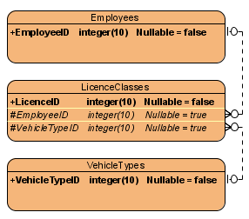
- Re-write all the code that generates the schedule to take advantage of this change. The code will not have to change every time a change happens to the licence table.

Part B: Preview (Please look up on the web)
Question 6
- Describe database normalization in 6 lines or less.

Database normalization is a technique for designing relational database tables to minimize duplication of data. In doing this, the database is also safeguarded from certain types of logical or structural problems such as keeping duplicated data consistent across the database.
(Steffen)

- What is 1st normal form. (6 lines or less)

A table is in 1st normal form when it contains a unique key that prevents duplication of rows and is without any nullable columns. Basically, it is a table that is free of any repeating groups.
(Steffen)

- What is 2nd normal form. (6 lines or less)

The table must already be in 1st normal form and none of the attributes are dependant upon a part of a candidate key. For example, if an Employee Skills table contained the attributes Employee, Skill, and Address, it would not be in 2nd normal form because the Address attribute would be duplicated many times and would be vulnerable to update anomalies.
(Steffen)

- What is 3rd normal form. (6 lines or less)

The table must already be in 2nd normal form. In addition to this, all attributes that are not dependent upon the primary key must be eliminated. For example, a table with Employee, Department, and Address would not be in 3rd normal form as Address is dependent on Department, which is a non-key field. To be in 3rd normal form, this would be split up into two tables with {Employee, Department} and {Department, Address}.
(Steffen)

Question 7
What is a data warehouse? (4 lines or less)
What is data mining? (4 lines or less)
How is a data warehouse different than an operational database? (6 lines or less)

Question 8
Draw a star schema. Explain the logic behind it and summarize how it helps in data warehousing. (12 lines or less)

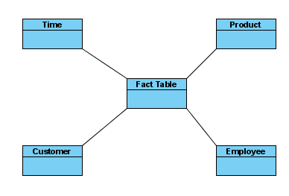
The star schema creates a virtually multidimensional database model from an existing relational database. The central fact table is related to the surrounding dimension tables through its composite primary key, which is derived from the primary keys of each dimension table. This design enables analysts to query the data across different dimensions (e.g. Summarize sales data for all products across time or summarize sales data for all employees across products). This design also enables analysts to query facts through the attributes of the smaller dimension tables, thereby facilitating data retrieval. Data warehouses can have many fact tables in order to capitalize on the efficiency of this design.
(Kathleen)
Submission Requirements
Due Tuesday January 29 at 10:00PM. Please submit everything in one document marked week3 discussion questions final. All group members must participate. List a summary of questions and persons responsible for each at the beginning of the document. List the name of the person who answered by each question. Split the questions evenly as possible (within reason).

